**WEEK-2**

(Implemented in Eclipse )

**1)Junit Testing**

Exercise 1:Setting up JUnit:

1. Created a new Java project in Eclipse IDE

2. Added JUnit dependency to your project.

pom.xml

<projectxmlns="http://maven.apache.org/POM/4.0.0"xmlns:xsi="http://www.w3.org/2001/XMLSchema-instance"xsi:schemaLocation="http://maven.apache.org/POM/4.0.0 https://maven.apache.org/xsd/maven-4.0.0.xsd">

<modelVersion>4.0.0</modelVersion>

<groupId>com.example</groupId>

<artifactId>JUnitDemo</artifactId>

<version>0.0.1-SNAPSHOT</version>

<dependencies>

<dependency>

<groupId>junit</groupId>

<artifactId>junit</artifactId>

<version>4.13.2</version>

<scope>test</scope>

</dependency>

</dependencies>

</project>

3. Created a new test class in your project.

MyFirstTest.java

**importstatic**org.junit.Assert.*;

**import**org.junit.Test;

**publicclass**MyFirstTest {

@Test

**publicvoid**sampleTest() {

*assertTrue*(**true**);

}

}

**Output:**

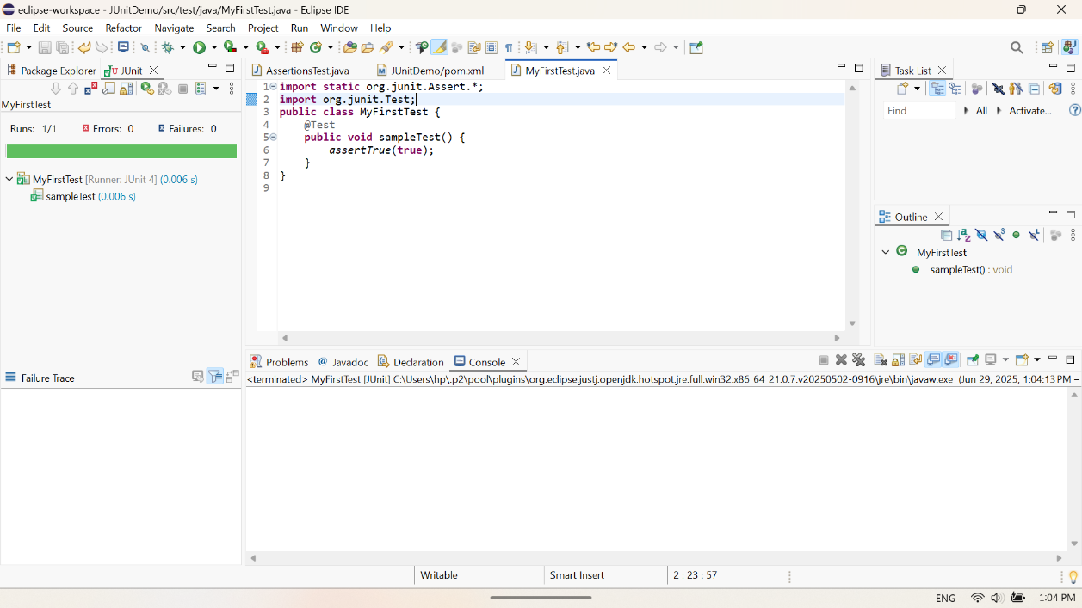

Exercise 3: Assertions in JUnit:

Write tests using various JUnit assertions.

**importstatic**org.junit.Assert.*;

**import**org.junit.Test;

**publicclass**AssertionsTest {

@Test

**publicvoid**testAssertions() {

*assertEquals*(5, 2 + 3);

*assertTrue*(5 > 3);

*assertFalse*(5 < 3);

*assertNull*(**null**);

*assertNotNull*(**new** Object());

}

}

**Output:**

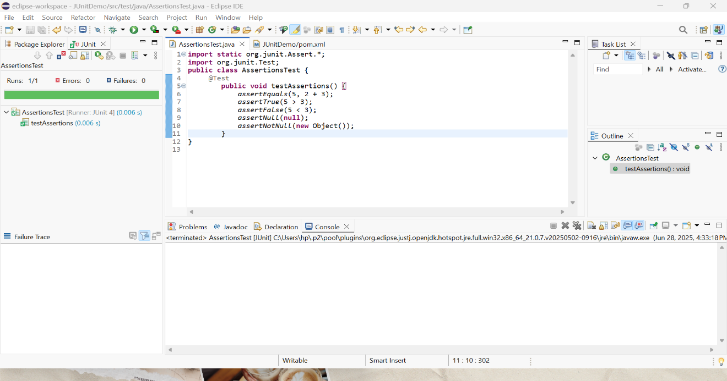

Exercise 4:Arrange-Act-Assert(AAA) Pattern,TestFixtures,Setup and Teardown Methods in Junit

Calculator.java

**publicclass** Calculator {

**publicint**add(**int**a, **int**b) {

**return**a + b;

}

**publicint**subtract(**int**a, **int**b) {

**return**a - b;

}

}

CalculatorTest.java

**import**org.junit.Before;

**import**org.junit.After;

**import**org.junit.Test;

**importstatic**org.junit.Assert.*;

**publicclass**CalculatorTest {

**private** Calculator calc;

@Before

**publicvoid**setUp() {

// Arrange: Setup before each test

calc = **new**Calculator();

System.***out***.println("Setup done");

}

@After

**publicvoid**tearDown() {

// Cleanup after each test

calc = **null**;

System.***out***.println("Teardown done");

}

@Test

**publicvoid**testAddition() {

// Act

**int**result = calc.add(2, 3);

// Assert

*assertEquals*(5, result);

}

@Test

**publicvoid**testSubtraction() {

**int**result = calc.subtract(10, 4);

*assertEquals*(6, result);

}

}

**Output:**

